Spotlight on Partners
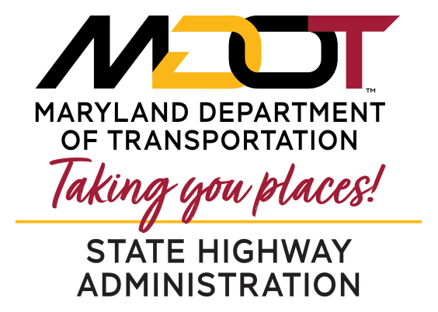
Walt Cervenka
Division Chief - Workforce
Management & Development
Office of Administration

Walt Cervenka, Division Chief for Workforce Management and Development, started as an Auto Technician student at CAT North.
Walt has been an amazing business partner with CAT North. Walt is a pioneer when it comes to creating apprenticeships and work study opportunities at the State Highway Administration (SHA). Walt’s vision is having CAT North students help bridge the workforce gap at SHA by giving students the opportunity to start a career with the SHA before they graduate.
Walt and his team worked very hard to get the first approved youth apprenticeship program with the State Highway Administration in Maryland. SHA currently has two CAT North Auto Tech students participating in the apprenticeship program. Walt’s goal is to expand this opportunity to 12 students next year.
Walt is also looking to create work study opportunities to include engineering opportunities for Drafting and Design, building maintenance for construction students, and graphic design and print opportunities.
Walt understands the importance of building relationships with the students at CAT North. Walt volunteers to do presentations, attend Open House, participate in Program Advisory Committees, and attend apprenticeship and career fairs.
CAT North would like to thank Walt Cervenka and his team for supporting the students and programs at CAT North.

