Spotlight on Partners
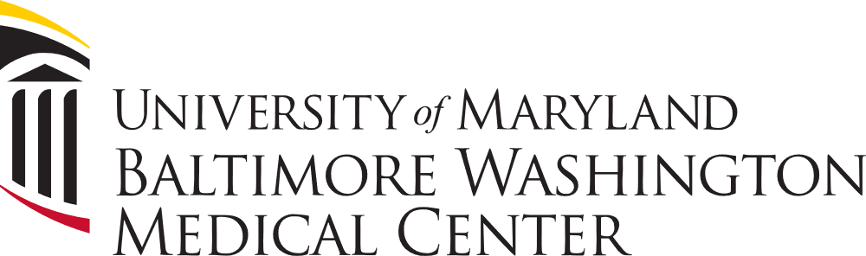

As, Volunteer Services and Patient & Family Advisory Manager at UM Baltimore Washington Medical Center, Grant Dopheide is providing new career pathways for Academy of Health (AOH) students at Baltimore Washington Medical Center (BWMC).

Grant has been the driving force behind creating opportunities for students to obtain entry level positions and volunteer opportunities at BWMC. This experience along with the student’s program at CAT North is providing high school students a career pathway into the medical field.

As a new business partner, Grant has helped with student interviews, being a member of the Program Advisory Committee, presenting at Open House, doing presentations for the AOH students, and inviting students to job fairs at the hospital so our students can meet with the leadership team.

Grant believes in building the workforce at BWMC and giving back to the local high school students. This is why he is creating opportunities for AOH students at CAT North. Students can start by helping with transporting patients and being part of the environmental team. As students earn their medical certifications, the plan is to move the students into a special Student Extern – Patient Care Assistant role.

“The primary goal would be to create an entry point for certified high school students to join our organization in a junior clinical role that would allow them to become Primary Care Assistants upon graduation and then progress to Primary Care Technicians and eventually Registered Nurses, by providing them coaching and tuition assistance along the path.”

CAT North would like to thank Grant Dopheide and his team for supporting the students and programs at CAT North.

