Spotlight on Partners
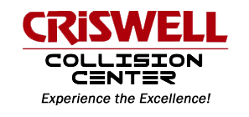
“Our objective with every vehicle that comes into our facility is to repair it to the highest standards and in a timely manner. We are going to do everything in our power to make the repair process as pleasant as possible.”

Kevin Marvin, Collision Center Manager, has been in the collision repair industry for more than 30 years and with the Criswell group since 2008.
Kevin has been an amazing business partner with the Auto Collision and Refinishing Program at CAT North. Kevin has hired multiple students for work study opportunities, he opens his shop for student field trips, attends Program Advisory Committee Meetings, and helps with student interviews and job shadowing. Kevin has volunteered countless hours to ensure the students at CAT North have industry support.
Crisswell Collision Center is a great place for CAT North students because they believe in encouraging a team culture, provide technician training, they use state of the art tools and equipment, and they teach students how to be a professional auto body technician.

CAT North would like to thank Kevin Marvin and his team for supporting the students and programs at CAT North.
